Trainer Report:

Soweto Peer Coach Programme Partners in Learning

Session 7 & 8 Report by Nomty Gcaba

Date : 16 & 17 August 2008

Attendance
7 Educators attended.
1 Principal from Reasoma High School

The venue
The venue was good.
I received 6 laptops from STIC.
Only two of them had power cords. So during the training power cords had to be exchanged.
One of the laptops was not using English interface but Afrikaans interface and none of the expected participants was an Afrikaans speaking. Apart from that the known password could not be accepted by that laptop.
One of them had Vista and it was for ever freezing.
Three of them looked as if they had just been formatted and they only had Windows XP without drivers and MS Office.

It looked as if those laptops had not been used for some time and they were just reserves. We tried to sort out some of these problems though, hence leaving the office at 22:00.

Since these laptops were not working we then borrowed office laptops and 2 other laptops were borrowed from SAIDE. There we cables all over and making it difficult to move freely. Hard as it is Peer Coaches were very calm and the training went smooth. On the last day we finished at 18
Hrs

Training
- The session for two day involves the following activities:
- Identify how coaching fits into an effective staff development model by participating in a discussion with principal and colleagues.
- Compare their school's professional development activities to teacher ICT integration competencies and the e-School implementation.
- Develop two or three steps to improve their school's professional development efforts and their coaching programme.
- Evaluate online professional development resources that match the needs of collaborating teachers and post them to the Portfolio.
- Discuss what made a coach and teacher collaboration successful.
- Participate in a collaborative activity to write and publish an article for the Coaching Chronicles.
- Inform the group of the benefits and pitfalls of associated with participating in a selected online collaborative project.
- Identify (list) at least three benefits of participating in an online, collaborative activity.
- Identify an example of a classroom collaborative project appropriate to a selected grade level and state the benefits and pitfalls associated with this type of project.
- Write at least one new goal or refine an existing goal for collaborating teachers and themselves

The first activity on whether Effective Professional development like or not like a space expedition, the points discussed by two groups were very similar in that they both mentioned that, Both require training, teamwork, commitment, preparations, and constant monitoring and they professional development is not like the space expedition in that it focuses mostly on the mental and physical state of the individual and that it require some expertise. The activity was good in that in make peer coaches think and understand what it that is involved in their duties is.
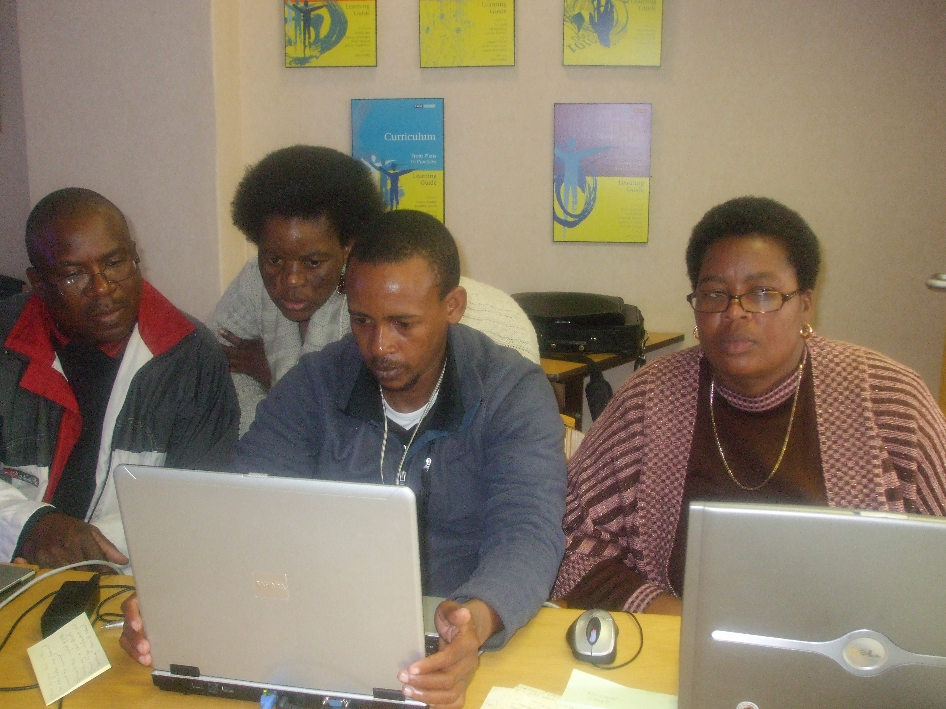
In assessing the level of profession learning community peer coaches use the professional development matrix.
All the school ranged between 0 and 1 and just the few ranges in 2.

This means that the profession development levels are very low in all these school. The numbers of elements used in the Monteview Video were also not strong in all the schools; however some elements that they saw can be implemented in their classes.
Peer Coaches have problems working with their collaborative educators, on peer coach managed to come up with a lesson even though there are no resources. He said he was going to wait until he is able to get resources before that lesson can be used in class.

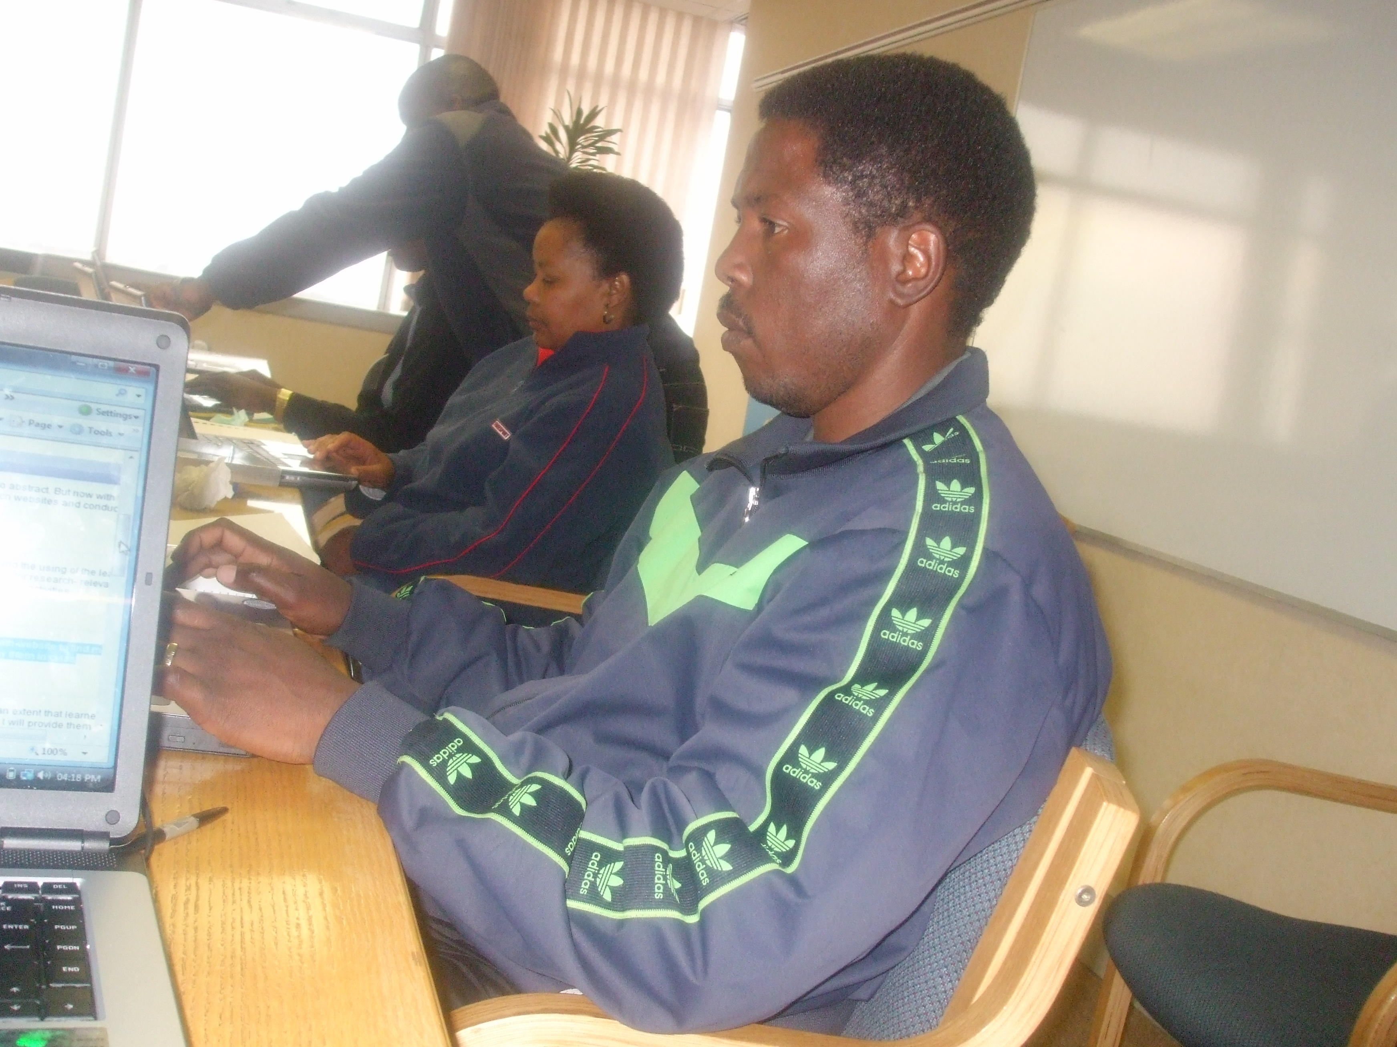
At the moment neither one of these peer coaches have internet in their schools. This has disturbed the flow of training and also they are not enthusiastic to enter the competition since it’s difficult to get the information that they want for learners and collaborating teacher.
In session eight morning hours were spend in designing the E-zine. Even though front page was loaded in other computers for some reasons it was not opening and this resulted to them using the publisher and the Microsoft word. Peer coaches will be working on their E-zine again using front page.
Peer coaches also spent time exploring collaboration resources, pond video make it very clear for them and they then come up with many ideas on how they can make it work in their classrooms. The challenge also is still internet.

Session 7

We value your feedback on the usefulness of Session 7. Please respond to the questions below to help us assess and improve our program.

First we would like to know to what extent you found the components of today’s session useful to you as a coach.

Session 7 Activity | Usefulness
 | Extremely useful | Mostly useful | Somewhat useful | Slightly useful | Not at all | Not sure
Discussion on effective school-based professional development—in order to understand attributes needed to implement a new model of professional development that can be supported by coaching | 1 | 4
Discussion on the Montview Video and School-based Professional Development Standards—in order to set a context to evaluate my school's professional development program | 1 | 3 | 1
Professional development reflection exercise and action planning—in order to guide our school team in planning for the implementation of effective school-based professional development | 3 | 2
“Reflection and analysis” protocol activity—in order to assess a successful collaboration experience, and how collaboration affects student learning. | 2 | 3

Please assess the quality of the following aspects of today's session by indicating how much you agree or disagree with each statement

 | Strongly Agree | Agree | Unsure | Disagree | Strongly Disagree
- Overall, there was an appropriate blend of presentations and hands-on activities | 3 | 2
- The facilitator offered information in a clear and organized fashion | 4 | 1

Please share any other comments you have.

- the fact that it was hands on made it more interesting
- I am grateful for the opportunity. Hope to improve teaching and learning

Session 8

We value your feedback on the usefulness of Session 8. Please respond to the questions below to help us assess and improve our program.

First we would like to know to what extent you found the components of today’s session useful to you as a coach.

Session 8 Activity | Usefulness
 | Extremely useful | Mostly useful | Somewhat useful | Slightly useful | Not at all | Not sure
- Writing and publishing an article in the Coaching Chronicles e-Zine—in order to learn about the benefits of participating in a collaborative project | 5 | 1
- Seeing examples of classroom collaborative projects—in order to help me learn to assess whether collaborative projects are well designed | 4 | 2
- Reviewing the Coaching Tools Resources—in order to identify resources to share with teachers in the future | 2 | 5
- Goal setting activity—in order to further develop my coaching plan | 3 | 3

Please assess the quality of the following aspects of today's session by indicating how much you agree or disagree with each statement

 | Strongly Agree | Agree | Unsure | Disagree | Strongly Disagree
- Overall, there was an appropriate blend of presentations and hands-on activities | 4 | 2
- The facilitator offered information in a clear and organized fashion. | 5 | 1

Please share any other comments you have.

The session was very much interesting such that peer coaches did not even want to leave the computer at tea and lunch time. They complained that time went so quickly and it interrupted our learning. Everyone was so hands-on and wanted to do more as there is so much that can still be done . Unfortunately this was our last session and we enjoyed the company of our facilitator (Nomty). She has been very informative throughout the whole programme. When we first started we thought that this course (Peer Coaching) was going to be tedious and boring, but we have found it very interesting and highly informative.

Session 7

We value your feedback on the usefulness of Session 7. Please respond to the questions below to help us assess and improve our program.

First we would like to know to what extent you found the components of today’s session useful to you as a principal

Session 7 Activity | Usefulness
 | Extremely useful | Mostly useful | Somewhat useful | Slightly useful | Not at all | Not sure
- Discussion on effective school-based professional development—in order to understand attributes needed to implement a new model of professional development that can be supported by coaching | x | - x
- Discussion on the Montview Video and School-based Professional Development Standards—in order to set a context to evaluate my school's professional development program | x
- Professional development reflection exercise and action planning—in order to guide our school team in planning for the implementation of effective school-based professional development |  | X

Please assess the quality of the following aspects of today's session by indicating how much you agree or disagree with each statement

 | Strongly Agree | Agree | Unsure | Disagree | Strongly Disagree
- Overall, there was an appropriate blend of presentations and hands-on activities |  | x
- The facilitator offered information in a clear and organized fashion. | x

6. Please share any other comments you have.
I sincerely hope that this information and training from the participants will be of benefit to our schools. ICT today is not a luxury but a sine qua non. Sorry to see that my peers (principals or deputies ) from other institutions could not attend as this is an eye-opener to the SMT. Thanks for the opportunity granted to me to attend this session……Cecil Sepuru.

